**Portable file Manipulator User Guide**

Note:

* For a safe user on your computer, be sure to read the instructions before use.
* The Types of the instructions are clear and well illustareted.

Project team:

Osamah Al-Ghammari.

Kubra Kose.

Aysenur Betul Yildirim.

**Using this manual:**

1. Understand how the program runs.
2. Displaying the interface on your computer.
3. How to use the program through the user guide.

**Contents:**

1. Before use instructions.
2. The Main menu.
3. Create a file.
4. Delete a file.
5. Rename a file.
6. Copy a file.
7. Move a file.
8. Editing text files:
9. Append text to the file.
10. Insert text in a specific position.
11. Remove all text in a file.
12. Show the content of the text file.
13. Help utilities.
14. **Before use instructions:**

This program was designed to conduct several user functionalities through a common window through any system such as Windows or iOS. It eases some jobs for the user whether creating a file, copying or moving etc. However, before we run into that, the user shall know which item he has to select after downloading the code.

For that, a main or a father function was created to call all functionalities. It is called $in.c$. It is the main root to run when the user needs to do his jobs. The other files are just the sub-root codes which are mainly called in $main.c$

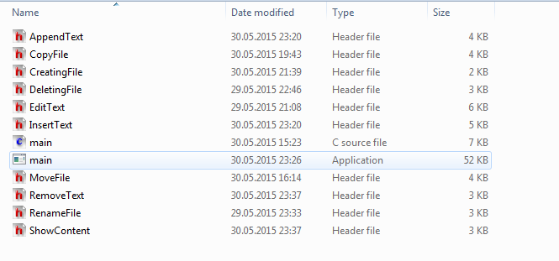

As it can be shown above, $main.c$ is the c blue file in the middle which shall be run by the user. The other files are just the header files supporting $main.c$.

1. **The main menu:**

After clicking on the $main.c$ a black screen connected to the command prompt of that system shall run and shows the following:

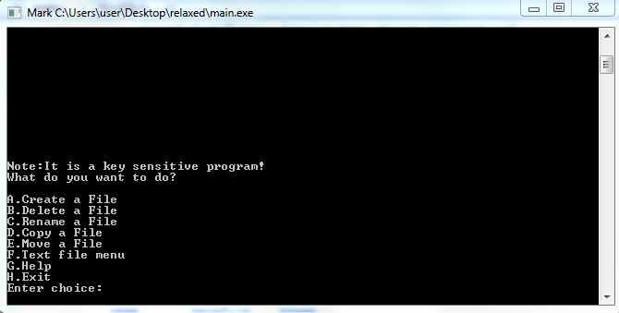

As it can be shown above, the program is a key sensitive. By which is meant, the user has to enter A, B, C, D, E, F, G or H. If there is an input mistake, the program returns nothing and returns to the main menu as above. The program clears the screen, of course without using a system call, once the user chooses one of the options and start working in the functions as they will be all described later.

1. **Create a file:**

After entering “A” from the main menu, the user shall enter the name of the file he/she wishes to create as follows:

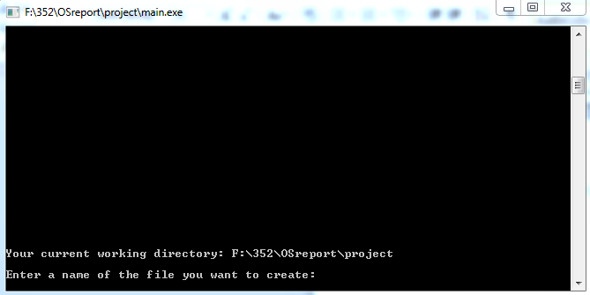

As it can be seen, it shows the current working directory where your file will be created.

After inserting the right files which DOES NOT have any duplicates in the current directory, it shall print the success of the job.

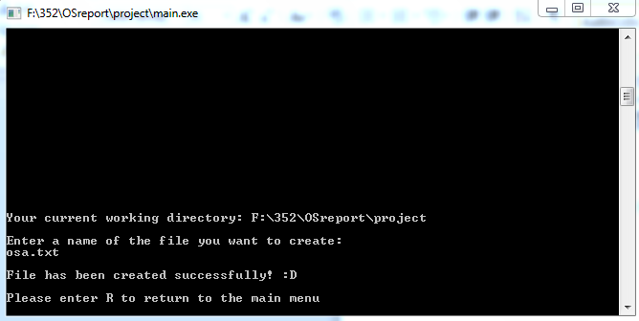

The user shall enter “R” to return to the main menu.

1. **Deleting a file:**

After Entering “B” from the main menu, a screen showing the current working directory and the files inside that directory to ease the process of deleting a specific file that the user desires to delete.

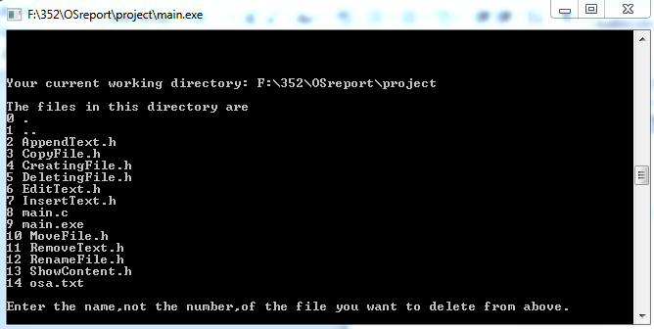

The user has to enter the file name, not the number as it is shown in the screen.

As it can be seen then, it shows the success of the process of deleting the file unless the file doesn’t exist, the program then returns an error.

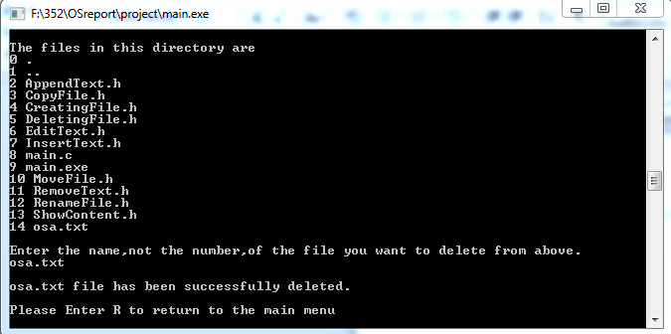

The user shall enter “R” to return to the main menu.

1. **Renaming a File:**

Renaming the file is accessed through entering “C” in the program. It shows the current directory and the contents of the directory. The user shall enter the name of the file he desires to rename.

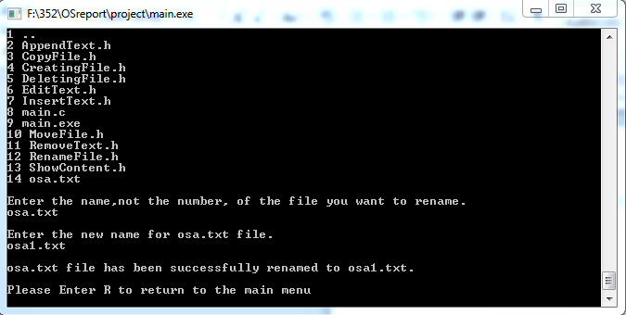

As it can be seen, the program prompts the user the new name for the file. Of course, the file has to exist in the current working directory. Not only that, in case the new name exists already in the current directory, it raises an error so the user can choose another name for his file.

1. **Copying a file:**

“D” is the shortcut to do that as the main menu tells us. The current working directory shall be showed. There is a twist was made here which is the user can copy his file to any other directory or in the current directory. How?

First, just enter the name of the file you desire to copy. In our case, we chose osa.txt

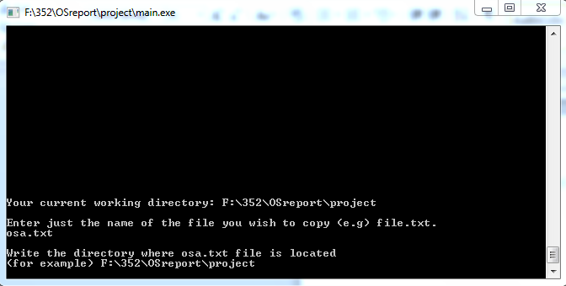

As it can be seen, the user has to enter the directory where his file exists. Then, he has to enter the destination directory where he wants to copy his file. However, the user must not forget to add “/” at the end of the destination directory. Otherwise, it will not be copied.

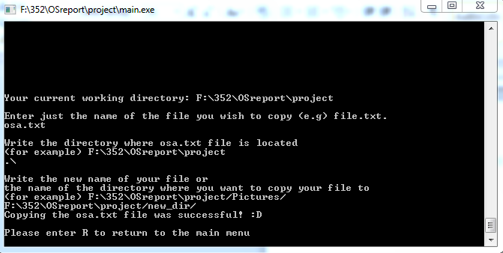

1. **Moving a file:**

Moving the file isn’t that much different from copying process. Once the user enter “R” from the main menu and the screen prints the current directory plus to the files in that file, the user has to enter the name of the file he desires to move. The user has to enter the directory where his file exists and add “/” to the end. At it shows below:

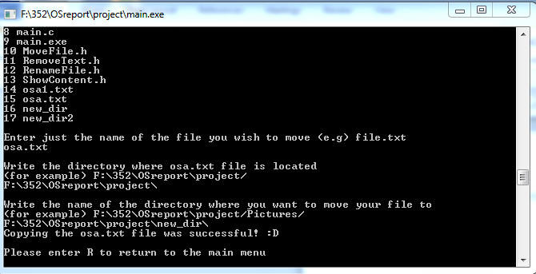

1. **Editing text files:**

In this section, once the user enters “F” , another interactive screen will be shown. These options are for the text file edition.

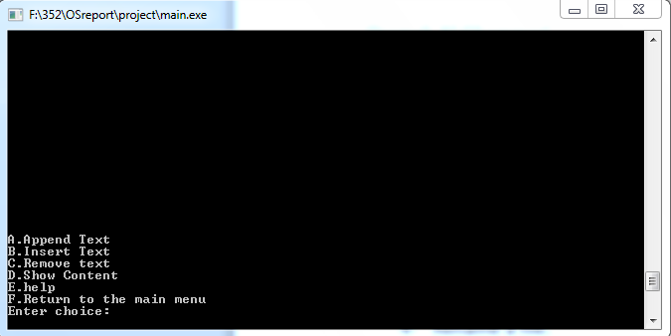

1. **Append text to the file:**

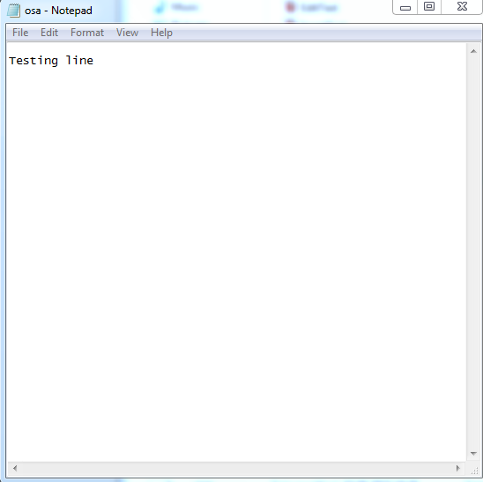Once the user enters “A” from the text editing menu, the user desires to append a text to his file. Let’s assume we are having this line on the file on the left.

We would like to add another line to this. The user has to enter the file name in the current working directory.

Let’s append $“Here is another line”$ to the file on the left.

The screen shall show all the steps needed for that as the following screen shows.

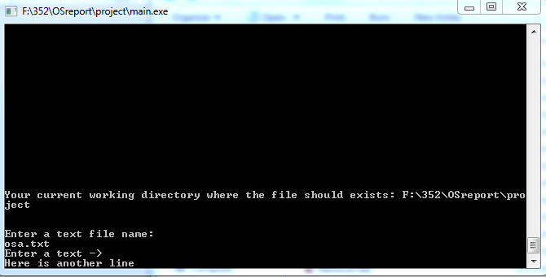

After that, the screen shows that the appending process is successful. You can check your file and see.

The function provides the feature of creating the file if it doesn’t exist. Thus, it helps the user in some other aspects he needs.

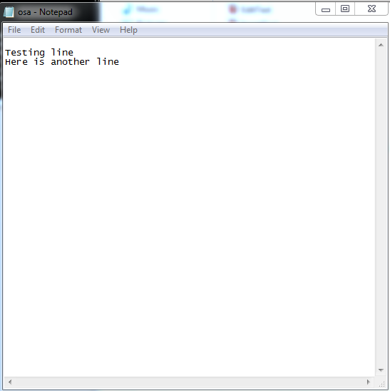

1. **Insert text to the file:**

Once the user enters “B” from the editing menu, the process isn’t much different things from appending the file process. The user has to enter the file name and the function will print the file contents to the user in order to check where he wants to add his text. The function provides line by line insertion in addition to the index insertion. To illustrate; the following screen is printed once the user enters the correct file name.

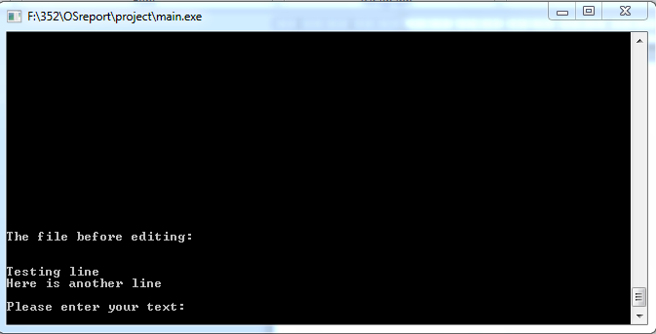

Let’s assume I would like to insert $"Osamah is adding"$ to the second line of the file. The index shall be 8 which is after $"Here is"$.

Note: if the user does not provide the correct line, the program will not insert the line.

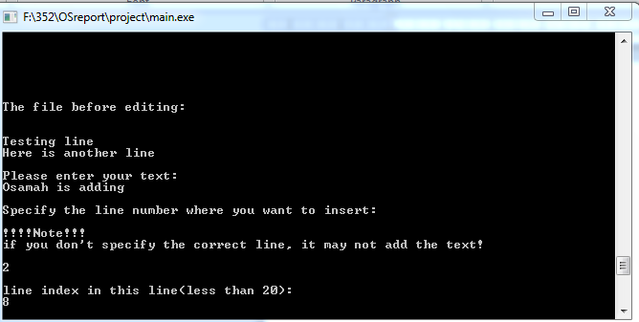

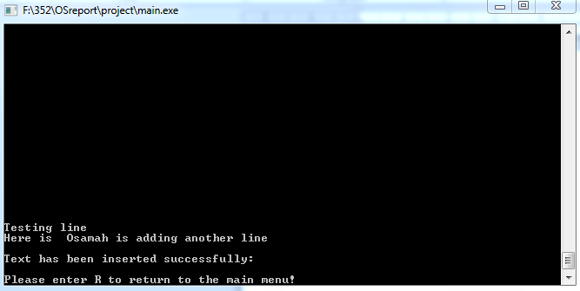

It can be seen that the text has been inserted successfully.

1. **Remove all text in a file:**

The user has to enter “C” in order to remove all of the text file contents. Then, he/she will be prompt to enter the text file name. In case that file exists, it will remove all the contents from that file automatically.

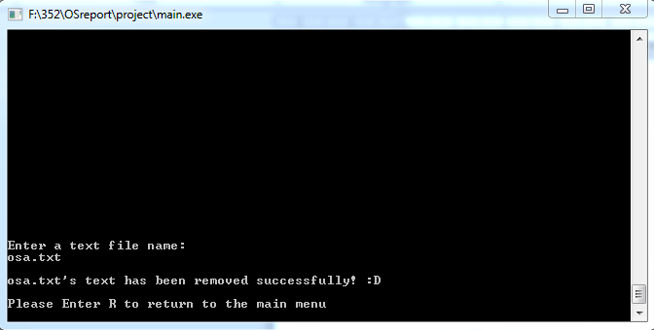

1. **Show the content of the text file:**

The user has to enter “D” in order to show the contents. Then, he/she will be prompt to enter the text file name. In case that file exists, it will prompt the user to specify the number of the lines that will be shown.

Let’s say we need to see the contents line by line, the user shall enter 1 then.

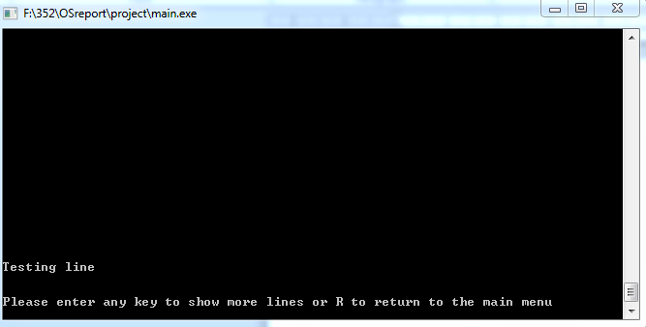

As it can be seen, it shows the line after the space line, the user shall enter any key to continue. Let’s say $e+Enter$

The lines will be shown gradually with an increasing number if there are a lot of lines.

1. **Help Utilities:**

Both of the help utilities in the main and the sub-main are provided. The user has to write the command name and add ? to the end of the command.

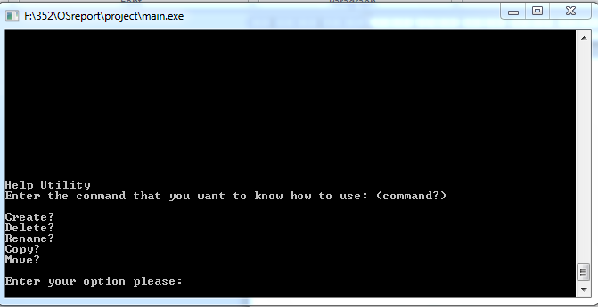

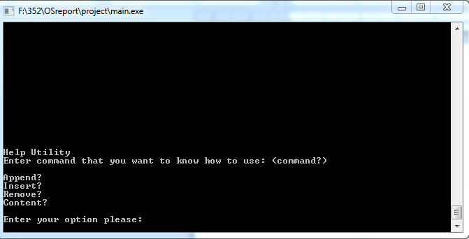

That is all from the project. ☺